Because it’s in a folder that is part of the overall PSA drive, I don’t know how to “force suggestion mode”, maybe you do?

* Yes, I can do this, although you should have the power. I added Katja directly to the folder.
* Then you should be able to make a comment only link (which forces suggestion mode):

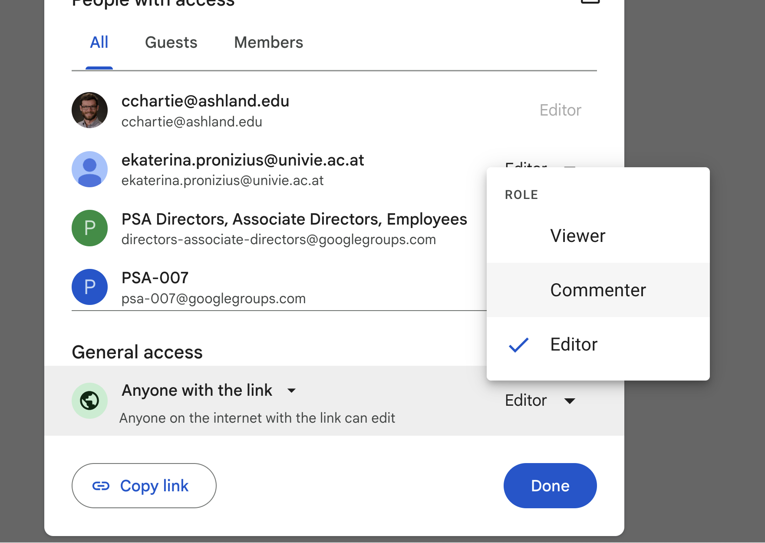

* It gives you a warning about the overall folder, which is fine (solved by adding Katja directly, who is the only other person not on the SPAML admin team that needs editable access that I’m aware of).

Remaining major to do’s are:

* Code review (I included all the scripts in the Multiverse > Validation Survey > Analyses folder). It would be nice if someone could double check the code (if only some spot checks). I was somewhat surprised by how consistent the results were, compared to most other multiverse analyses, but presumably the large sample size plays a role.
* Make an OSF project an upload materials there (I’ll do that, e.g., when contributors are reviewing the manuscript). We should decide what to share publicly and what not.
* Send out paper to contributors. I have been thinking about this for a bit, and came up with the following suggestion: as you can see, the current version of the manuscript is just an MS Word doc (except the appendix table, because I couldn’t be bothered to make it in Word; you can find the table in the Multiverse > Validation Survey > Manuscript folder). After you two have provided feedback, and we revised the paper, I’d send it to all contributors asking to focus on the content, and potentially some things like wording or typos, but not any stylistic stuff like “spacing isn’t APA, or references aren’t APA (there is no reference list even at this point). Next, I’ll revise the paper based on contributors’ comments and put it in Rmd using papaja. Then, I’d send it back to the contributors for a final check (is my affiliation ok, do I agree with this version being submitted,…). Would that make sense?

Sorry, I didn’t provide any clarification regarding the code yet. So, Analyses.R is the masterfile, that sources all the other .R files. But, I commented most sources commands out, because they take a long time to run (Processing SPAML.R not that long though). So, to check everything, those should ideally be uncommented and checked. The Processing SPAML.R takes en_full_data.csv.gz and de_full_data.csv.gz as input. I didn’t upload them to google drive folder because they are pretty large files. But I can’t find the link to those files anymore @Erin: where are they stored again? Alternatively, I could upload them in the google drive, or I could upload the processed datasets en_SPAML.csv and de_SPAML.csv, but they too are pretty large. What do you think?

I think you should upload the files somewhere, but I'm not sure how large the PSA storage is. What about using OSF? I just want to rerun the code, but if you think it’s not necessary, then don’t worry about it. Personally, I can't check the code by just looking at it; I need to run it. And I can't do that without these files.

*the reason for framing it as a tutorial is because we'd aim for Psychological Methods, which has a tutorials article type.*

Cool, thanks, I forgot! Then it should be a "tutorial" throughout the manuscript. The switch between "guidelines" and "tutorial" confused me a lot. But maybe it's just me. How do these two words sound to the natives, @**Erin**? :D Can they be used as synonyms?